Software Requirements Specification Template

Software Engineering

The following annotated template shall be used to complete the Software Requirements Specification (SRS) assignment.

**Template Usage:**

Text contained within angle brackets (‘<’, ‘>’) shall be replaced by your project-specific information and/or details. For example, <Project Name> will be replaced with either ‘Smart Home’ or ‘Sensor Network’.

Italicized text is included to briefly annotate the purpose of each section within this template. This text should not appear in the final version of your submitted SRS.

This cover page is not a part of the final template and should be removed before your SRS is submitted.

Movie Ticket Website Assignment

Software Requirements Specification

Ver. 1

September 11th, 2025

Group 1

Seth V., Christena B., Oscar D.

Prepared for

CS 250 - Introduction to Software Systems

Instructor: Gus Hanna, Ph.D.

Fall 2025

# Revision History

|  |  |  |  |
| --- | --- | --- | --- |
| **Date** | **Description** | **Author** | **Comments** |
| 09/11/25 | Ver. 1 | Seth Vanegas | Creation of Document |
| 09/18/25 | Ver. 1 | Seth Vanegas | First Edits For Sec. 1,2,3 |
| 09/18/25 | Ver.1 | Christena Bell | First Edits For Sec. 1,2,3 |
| 09/25/25 | Ver. 1 | Oscar DeHamer | Last Touches Before Submission |
| 09/25/25 | Ver. 1 | Seth Vanegas | Last Touches Before Submission |
| 09/25/25 | Ver. 1 | Christena Bell | Last Touches Before Submission |

# Document Approval

The following Software Requirements Specification has been accepted and approved by the following:

|  |  |  |  |
| --- | --- | --- | --- |
| **Signature** | **Printed Name** | **Title** | **Date** |
|  | Seth Vanegas | Computer Scientist |  |
|  | Dr. Gus Hanna | Instructor, CS 250 |  |
|  |  |  |  |

**Table of Contents**

Revision History iii

Document Approval iii

1. Introduction 1

1.1 Purpose 1

1.2 Scope 1

1.3 Definitions, Acronyms, and Abbreviations 2

1.4 References 3

1.5 Overview 4

2. General Description 5

2.1 Product Perspective 5

2.2 Product Functions 6

2.3 User Characteristics 7

2.4 General Constraints 9

2.5 Assumptions and Dependencies 10

3. Specific Requirements 11

3.1 External Interface Requirements 11

3.1.1 User Interfaces 11

3.1.2 Hardware Interfaces 12

3.1.3 Software Interfaces 12

3.1.4 Communications Interfaces 13

3.2 Functional Requirements 13

3.2.1 <Functional Requirement or Feature #1> 13

3.2.2 <Functional Requirement or Feature #2> 13

3.3 Use Cases 16

3.3.1 Use Case #1 16

3.3.2 Use Case #2 17

3.4 Classes / Objects 20

3.4.1 <Class / Object #1> **Error! Bookmark not defined.**

3.4.2 <Class / Object #2> **Error! Bookmark not defined.**

3.5 Non-Functional Requirements **Error! Bookmark not defined.**

3.5.1 Performance **Error! Bookmark not defined.**

3.5.2 Reliability **Error! Bookmark not defined.**

3.5.3 Availability **Error! Bookmark not defined.**

3.5.4 Security **Error! Bookmark not defined.**

3.5.5 Maintainability **Error! Bookmark not defined.**

3.5.6 Portability **Error! Bookmark not defined.**

3.6 Inverse Requirements 23

3.7 Design Constraints 23

3.8 Logical Database Requirements 23

3.9 Other Requirements 23

4. Analysis Models 23

4.1 Sequence Diagrams 23

4.3 Data Flow Diagrams (DFD) 23

4.2 State-Transition Diagrams (STD) 23

5. Change Management Process 23

A. Appendices 23

A.1 Appendix 1 24

A.2 Appendix 2 24

# 1. Introduction

## 1.1 Purpose

This Software Requirements Specification (SRS) delineates the scope, features, constraints, and quality attributes of the San Diego Sunset Drive-In Management System (SDSDIMS). It establishes a definitive baseline for the processes of design, implementation, and testing. The stakeholders encompass customers, staff, managers, and developers.

## 1.2 Scope

The software product to be developed is the San Diego Sunset Drive-In Management System (SDSDIMS). It is a comprehensive system for managing ticketing, parking reservations, concessions, scheduling, and reporting for a retro-style outdoor drive-in theater.

**System Capabilities**

* Permit customers to browse movies, reserve parking spots, and purchase tickets or concessions either online or on-site.
* Distribute digital tickets featuring QR codes and barcodes to facilitate seamless validation at entry points.
* Authorize personnel to scan and validate tickets, facilitate walk-up sales, and oversee concession inventory.
* Provide managers with tools for scheduling movies, configuring pricing and promotions, and generating operational reports.

The SDSDIMS will not manage external vendor relationships, third-party concession supply orders, or the streaming of movies. Additionally, it will not support functionalities beyond the scope of a single-location drive-in, such as integration across multiple theaters.

The application is customized to support the operations of a drive-in theater featuring a nostalgic “sunset” theme, emphasizing both customer convenience and operational effectiveness.

* **Customer Benefits**: Enable seamless browsing, reservations, and payments to minimize on-site wait times and guarantee the availability of preferred parking.
* **Staff Benefits**: Streamline ticket validation through mobile and POS devices, facilitating efficient tracking of concession sales.
* **Managerial Benefits**: Deliver parameter-driven, user-definable reports (e.g., sales by showtime, parking utilization, concession stock levels) with a turnaround time of less than two hours. Enable online entry of scheduling and pricing parameters.
* **System Goals:** To ensure reliability with a 99.9% uptime, maintain security in compliance with PCI-DSS standards, and support scalability to accommodate up to 2,000 concurrent users during peak events.

By delineating these objectives and constraints, the scope of the SDSDIMS guarantees that the system caters to fundamental operational requirements while circumventing superfluous complexity, aligning with best practices in software engineering for clarity and maintainability.

## 1.3 Definitions, Acronyms, and Abbreviations

**Definitions:**

* **Parking Spot Hold** - A temporary reservation of a drive-in parking spot that expires if payment is not completed within a defined time window.
* **Showtime** - A scheduled instance of a movie presentation, defined by movie, start/end time, and assigned parking layout.
* **Digital Ticket (QR/Barcode)** - An electronic code issued upon payment that is scanned for entry validation.
* **Concession Item** - Any food or beverage product sold at the drive-in (e.g., popcorn, soda, candy).
* **Promotion Code** - A rule-based discount or offer applied to a customer’s order (e.g., “Buy 2 tickets, get 1 free”).

**Acronyms:**

* **SRS** - Software Requirements Specification
* **SDSDIMS** - San Diego Sunset Drive-In Management System
* **POS** - Point of Sale (cashier/staff terminal for sales)
* **ADA** - Americans with Disabilities Act (U.S. accessibility standard)
* **WCAG** - Web Content Accessibility Guidelines (W3C accessibility standard)
* **PCI-DSS** - Payment Card Industry – Data Security Standard (compliance for payment processing)
* **UI** - User Interface
* NFR – Non-functional requirment

**Abbreviations:**

* **Mgr.** - Manager
* **Wrk. -** Worker
* **Cust.** - Customer
* **Sys.** - System
* **Auth.** - Authorized (payment status)
* **Redeem.** - Redeemed (ticket status after scan)

## 1.4 References

The following documents and materials are referenced in this Software Requirements Specification (SRS) for the **San Diego Sunset Drive-In Management System (SDSDIMS):**

1. **CS250: Introduction to Software Systems - Lecture 1 Notes**
   1. Title: *Lecture 1 - Introduction to Software Systems*
   2. Instructor: Dr. Gus Hanna, San Diego State University
   3. Date: Fall 2025
   4. Source: Provided on Canvas course site
2. **CS250 Assignment Guidelines**
   1. Title: *Requirements Specification Assignment and Rubric*
   2. Report: Assignment posted to Canvas
   3. Date: September 2025
   4. Publishing Organization: San Diego State University, Department of Computer Science
   5. Source: [Canvas course portal]
3. **NATO Software Engineering Conference Report (1968)**
   1. Title: *Software Engineering: Report of a Conference Sponsored by the NATO Science Committee*
   2. Date: October 1968
   3. Publishing Organization: NATO Science Committee
   4. Source: Provided in course readings
4. **Tutorialspoint Software Engineering Tutorial**
   1. Title: *Software Engineering Tutorial*
   2. Report Number: N/A
   3. Date: 2014
   4. Publishing Organization: TutorialsPoint (I) Pvt. Ltd.
   5. Source: Provided in PDF for CS250 course readings
5. **Frederick P. Brooks, Jr.**
   1. Title: *No Silver Bullet, Essence and Accident in Software Engineering*
   2. Report Number: IFIP Tenth World Computing Conference Proceedings
   3. Date: 1986 (reprinted in *The Mythical Man-Month*, Anniversary Edition, Addison-Wesley, 1995)
   4. Publishing Organization: Elsevier Science B.V.
   5. Source: Provided in PDF for CS250 course readings

## 1.5 Overview

This Software Requirements Specification (SRS) delineates the functional and non-functional requirements for the San Diego Sunset Drive-In Management System (SDSDIMS).

The remainder of the document is organized as follows:

* **Section 2: User Requirements:** Provides a comprehensive overview of the operational context, application environment, target platforms, assumptions, and constraints. This section emphasizes the system from the user’s perspective, ensuring clarity and professionalism in presentation.
* **Section 3: Functional Requirements:** Defines the system’s entities, properties, states, and interrelationships. It describes the expected capabilities in detail, including browsing showtimes, parking spot reservations, ticketing, concessions, scheduling, and reporting. Three representative **use cases** are included to illustrate system behavior from a user standpoint.
* **Section 4: Non-Functional Requirements:** Specifies quality attributes such as performance, usability, security, reliability, maintainability, and compliance. These requirements encapsulate system-wide characteristics that are not associated with individual features but are essential for overall success.

Subsequent assignments in CS250 will expand this Software Requirements Specification (SRS) to encompass design models, testing strategies, and maintenance considerations, thereby building upon the requirements documented herein. This structured approach ensures clarity, adherence to the course SRS template, and traceability for subsequent phases of the project.

# 2. General Description

This section provides an overview of the environment in which the San Diego Sunset Drive-In Management System (SDSDIMS) will operate, the categories of users expected to interact with the system, the overall functionalities of the product, as well as the assumptions and dependencies influencing the requirements. It does not specify detailed requirements but offers the essential context for their understanding.

## 2.1 Product Perspective

The San Diego Sunset Drive-In Management System (SDSDIMS) is an innovative, standalone solution developed to facilitate the operations of a single-site drive-in theater. It serves as a contemporary alternative to conventional, manual ticketing and scheduling procedures, consolidating essential business functions, including ticket sales, parking reservations, concession ordering, and reporting, into a unified system.

The system shall not be integrated as part of a larger multi-theater enterprise solution; however, it must be capable of interoperability with external services and technologies, including:

* **Payment gateways (e.g., Stripe, PayPal, or equivalent)** for secure processing of online and on-site transactions.
* **Email and SMS services** are provided for the delivery of digital tickets and customer notifications.
* **Barcode and QR code scanning hardware** employed for the validation of digital tickets at the theater entrance.
* **POS terminals and kiosks** aredesignated for walk-up sales and concession management.

The SDSDIMS is structured in three tiers:

1. **Customer- Facing Layer** – A responsive web portal and optional mobile application for browsing movies, reserving parking spaces, and purchasing tickets and concessions.
2. **Operational Layer** – Staff-facing point-of-sale applications and scanning tools that facilitate on-site sales and ticket validation.
3. **Management Layer** – An administrative dashboard intended for managerial use to configure schedules, establish pricing structures, develop promotional campaigns, and generate analytical reports.

Although the SDSDIMS functions as an independent product, it leverages best practices from analogous ticketing and entertainment management systems, such as online movie ticketing platforms and live event reservation systems. Its distinctive emphasis is on the drive-in theater experience, which necessitates specific considerations including parking spot reservations, open-air operations, and concession pickup coordination.

The product’s perspective aligns with IEEE Standard Requirements Specification (SRS) guidance: it delineates how the system integrates within its operational environment, specifies dependencies on external services, and elucidates the distinctions from related products.

## 2.2 Product Functions

The San Diego Sunset Drive-In Management System (SDSDIMS) offers comprehensive support for customer engagement, staff management, and executive oversight. At an overarching level, the system is designed to execute the following functions:

**Movie and Showtime Management**

* Display available movies, formats, and showtimes to customers.
* Allow managers to create, update, and publish showtimes along with assigned parking maps.

**Parking Spot Reservation and Ticketing**

* Present customers with an interactive parking map displaying real-time availability.
* Permit customers to select parking spaces, place temporary holds, and finalize ticket purchases.
* Issue digital QR/barcode tickets after successful payment.

**Payment Processing**

* Securely process payments through third-party gateways.
* Support multiple payment methods, including credit card, debit card, and mobile wallet.
* Utilize promotional codes and discounts as established by management.

**Concession Ordering and Inventory Tracking**

* Allow customers to pre-order concessions via online platforms or to make purchases on-site.
* Permit staff to document sales at point-of-sale terminals.
* Automatically regulate inventory levels and inform managers of low stock.

**Ticket Validation and Access Control**

* Ensure that personnel are equipped with scanning devices to authenticate digital tickets at the point of entry.
* Monitor redeemed tickets to prevent fraudulent re-use.
* Support offline validation with synchronization when connectivity is restored.

**Reporting and Analytics**

* Generate reports on ticket sales, parking utilization, concession sales, and promotion usage.
* Provide real-time dashboards for managers to monitor operational performance.
* Export data for financial and administrative purposes.

**System Administration and Configuration**

* Allow managers to configure user roles (customer, staff, manager).
* Ensure implementation of access control and authentication mechanisms, including multi-factor authentication specifically for managerial personnel.

Support the configuration of pricing tiers, promotions, and concession menus.

## 2.3 User Characteristics

The San Diego Sunset Drive-In Management System (SDSDIMS) is designed to be accessible to a diverse array of users, most of whom possess limited technical expertise. The system’s design prioritizes simplicity, clarity, and usability, ensuring effective interaction for all user groups.

### Customers

* **Profile**: The general public, encompassing families, young adults, and older generations.
* **Technical Skills**: Basic familiarity with web browsers, smartphones, and common payment methods.
* **Expectations**: The system offers straightforward navigation, a rapid checkout procedure, and a clear display of movies, showtimes, and parking options.
* **Design Consideration**: Interfaces shall be designed to be intuitive, mobile-compatible, and compliant with ADA/WCAG standards to accommodate a broad range of accessibility requirements.

### Staff (Cashiers, Attendants, Ticket Validators)

* **Profile**: Theater personnel responsible for ticket validation, concession sales, and customer support.
* **Technical Skills**: Moderate; trained to operate POS systems and mobile scanning devices but not anticipated to possess extensive technical expertise.
* **Expectations**: Efficient and error-tolerant tools that minimize transaction time and reduce manual entry.
* **Design Consideration**: Staff-oriented tools will employ simple workflows, prominently sized clear buttons, and facilitate offline ticket validation during connectivity disruptions.

### Managers/Administrators

* **Profile**: Theater managers are responsible for overseeing scheduling, pricing, promotions, and reporting.
* **Technical Skills**: Superior to customers and staff; skilled in utilizing web dashboards, spreadsheets, and report generation.
* **Expectations**: Access to configuration options, parameter-driven reporting, and secure administrative controls.
* **Design Consideration**: Management dashboards will offer structured workflows, customizable reports, and multi-factor authentication to enhance security.

**Overall Principle**:

All three user groups will engage with SDSDIMS via role-appropriate, user-friendly interfaces, guaranteeing that the system is accessible, efficient, and conducive to the drive-in theater’s nostalgic yet contemporary experience.

## 2.4 General Constraints

The development and operation of the San Diego Sunset Drive-In Management System (SDSDIMS) are subject to the following general constraints:

### Regulatory and Compliance Constraints

* **PCI-DSS Compliance**: All payment transactions are required to comply with the Payment Card Industry Data Security Standards. The system must not retain raw cardholder data.
* **ADA/WCAG Compliance**: Customer-facing applications are required to adhere to accessibility standards as specified by the Americans with Disabilities Act (ADA) and the Web Content Accessibility Guidelines (WCAG 2.1 AA).
* **Privacy Laws**: The system must adhere to relevant privacy regulations, such as the California Consumer Privacy Act (CCPA), including provisions for data access and deletion requests.

### Hardware and Platform Constraints

* The system must support standard POS terminals, ticket scanners, and receipt printers already deployed at the theater.
* Customer-facing portals are required to operate on contemporary web browsers such as Chrome, Firefox, Safari, and Edge, as well as on mobile devices, without the necessity for specialized hardware.
* Offline ticket validation must operate on staff mobile devices possessing limited local storage and processing capacities.

### Integration Constraints

* Payment processing shall depend on third-party gateways (such as Stripe and PayPal), necessitating compliance with their APIs, transaction limitations, and service accessibility.
* Email and SMS ticket delivery must integrate with external messaging services.
* Management is obliged to manually input showtimes, movies, and promotional content unless a compatible metadata source is adopted.

### Performance Constraints

* The availability of parking spots and showtime data must be updated across all channels within two seconds or less in order to prevent double-booking.
* The system must accommodate a peak load of approximately 2,000 concurrent customers without experiencing service degradation.

### Security Constraints

* All sensitive data, including user credentials and personal information, must be encrypted both in transit (TLS 1.2 or higher) and at rest (AES-256).
* Role-based access control must be enforced to prevent unauthorized use of staff or manager tools.
* Manager accounts are required to utilize multi-factor authentication (MFA).

### Development Constraints

* The SRS, design, and implementation will adhere to the course guidelines for CS250: Introductory to Software Systems.
* Development will be confined to a single-location deployment, as scalability across the entire chain is not anticipated in this version.
* The design must prioritize maintainability and modularity for future extensions, in line with software engineering best practices.

## 2.5 Assumptions and Dependencies

### Assumptions

* **Internet Connectivity**: It is assumed that dependable internet connectivity will be accessible at the venue for the synchronization of online ticketing, reporting, and concession sales.
* **Customer Device Access**: It is assumed that customers possess access to devices capable of receiving QR or barcode digital tickets, such as email-enabled devices or smartphones.
* **Payment Gateway Availability**: A minimum of one external payment processor (such as Stripe, PayPal) will be accessible and fully functional to facilitate secure financial transactions.
* **Standard Hardware Deployment**: Ticket scanners, receipt printers, and POS terminals are presumed to be available and operational at the theater.
* **Staff Training**: It is assumed that staff and managers will receive adequate training to utilize the POS systems, ticket validation tools, and reporting dashboards.

### Dependencies

* **Third-Party Services**: The system relies on external services such as payment gateways, email/SMS ticket delivery, and potentially concession vendor APIs to ensure smooth operation.
* **Regulatory Environment**: The requirements are contingent upon adherence to PCI-DSS, ADA, WCAG, and privacy regulations such as CCPA. Amendments to these standards may necessitate modifications to the system.
* **Movie Metadata**: Accurate movie titles, runtimes, ratings, and promotional content must be provided by theater management or trusted external sources.

# 3. Specific Requirements

## This section delineates the functional and non-functional requirements of the San Diego Sunset Drive-In Management System (SDSDIMS). Each requirement is distinctly identified, verifiable, and prioritized.

## 3.1 External Interface Requirements

### 3.1.1 User Interfaces

* **Display all movies currently playing**
  1. The system will allow the user to see all movies that tickets can be purchased for
  2. The system will allow the user to add any number of movie tickets to their cart
  3. The system will display the price of the tickets
* **Reserve parking spaces**
  1. The system will allow the user to choose a parking space to watch the movie from
  2. The system will display a map of all available parking spots
  3. The system will show how much a parking spot costs.
* **Use digital payment system to secure payments**
  1. The system will allow for the use of Visa and Mastercard
  2. The system will allow for the purchase of tickets, parking spots, and concessions
* **Generate tickets with unique QR codes**
  1. The system will generate tickets with unique QR codes that can be validated by staff
* **Login page**
  1. The system will have a login page that can be accessed by a user's email and a password they create
  2. The system will save users payment information for quicker transactions
  3. The system will allow for staff and managers to access systems that customers cannot
* **Scan and validate tickets**
  1. The system will have a QR code scanner that can validate customers tickets
  2. This system will only be able to be used by employees
* **Sell tickets on site**
  1. The system will allow for the sale of tickets on site facilitated by employees
  2. This system will only be able to be used by employees
* **Charts and data dashboard**
  1. The system will allow management to see tickets and other sales data and charts expanding on the data.

### 3.1.2 Hardware Interfaces

* **Barcode scanner**
  1. Used for validating tickets and purchased concessions by staff to enter the drive-in area
  2. Only used by staff

### 3.1.3 Software Interfaces

* **Email services**
  1. The system will send emails to users with accounts to tell them about upcoming movies
  2. The system will remind users of tickets they have purchased
* **Payment gateways**
  1. The system will have integration with payment gateways that allow the use of credit cards to pay for tickets, concessions, and parking
* **Database systems**
  1. The system will have a database system to be able to store ticket, parking and concession data
* **Reporting tools**
  1. The system will have compatibility with spreadsheets to be able to allow management users to understand and use data collected

### 3.1.4 Communications Interfaces

* **Web access**
  1. Allow for web access for all users
* **Mobile access**
  1. All for users to access the product from a mobile device
* **Ticket validation**
  1. The system allows for tickets to validated with a central server

## 3.2 Functional Requirements

## 3.2.1 Movie and Showtime Management

1. **Introduction**

* The system must allow management to update current movies that are playing so customers can browse the movies they can buy tickets for.

1. **Inputs**

* Mangers will be able to input data about the movies including the title, genre, rating, screen it will play on, start time and end time

1. **Processing**

* The system will store movies and showtime data in the database and publish the data to customer facing interfaces.

1. **Outputs**

* Customers will see the most updated list of movies and their showtimes.

1. **Error Handling**

* If movie data is missing, it will prompt the manager to input that data before saving it to the database.

### 3.2.2 Parking Spot Requirements

1. **Introduction**

* The system must allow customers to reserve their parking spots and purchase tickets for the showtime they choose.

1. **Inputs**

* Customer can select a showtime
* Customer can see an interactive parking map and select a spot to watch the movie
* Customer proceeds to payment

1. **Processing**

* System will temporarily place a hold on the selected parking spot during checkout
* After the payment goes through, the reservation is finalized and the ticket with an unique barcode is sent to the customer.

1. **Outputs**

* Confirmation page displaying the reserved parking spot and ticket details
* Digital ticket sent to the customer

1. **Error Handling**

* If payment does not go through, the reservation hold will expire, and the user will be prompted to try again
* If multiple users try to reserve the same spot, whoever finishes their payment first will get the spot.

### 3.2.3 Payment Processing

1. **Introduction**

* The system must be able to handle financial transactions for tickets, concessions, and parking reservations

1. **Inputs**

* Customer payment details

1. **Processing**

* System will validate the customers payment details
* It will save the transaction in a database

1. **Outputs**

* Payment confirmation will be sent to the customer via email

1. **Error Handling**

* If payment is declined, it will prompt the user to try another form of payment

### 3.2.4 Concession Ordering

### Introduction

* The system supports concession ordering online and on-site

1. **Inputs**

* Customers select the concession items that they want

1. **Processing**

* System reduces inventory levels for the purchased items
* Tells staff which items to prepare before the movie

1. **Outputs**

* A receipt that is provided to the customer
* Inventory reports for management

1. **Error Handling**

* If an item is out of stock, the system will prevent customers from ordering it

### 3.2.5 Payment Processing

1. **Introduction**

* The system must enable staff to validate tickets at entry points

1. **Inputs**

* Customer’s ticket with QR code
* Staff scans ticket with scanner

1. **Processing**

* System checks database for ticket validity
* Marks ticket as used

1. **Outputs**

* Staff device displays ticket confirmation

1. **Error Handling**

* If ticket is invalid the system alerts the staff

### 3.2.6 Reporting and Analytics

1. **Introduction**

* The system must provide managers with dashboards that show data about the drive-in

1. **Inputs**

* The manager selects the reports they would like to see, for example ticket sales, concession sales or the most often reserved parking spots.

1. **Processing**

* System will query the database to get the data
* The system will generate data visualizations to be used to understand the data.

1. **Outputs**

* On-screen dashboards that show the data

1. **Error Handling**

* If requested data is not available, the system will prompt the user to change what they are looking for.

**3.3 Use Cases**

### 3.3.1 UC-1: Reserve Parking and Purchase Tickets

* **Actor(s):** Customer (guest or registered)
* **Purpose:** The customer reserves a parking space and acquires tickets.
* **Preconditions:** Showtimes are available; the payment gateway is operational online.
* **Flow of Events:**  
  1. The customer selects a movie and a showtime.
  2. The system displays the available parking spots.
  3. The customer selects one or more spots; the system subsequently places a five-minute hold.
  4. The customer proceeds to the checkout, inputs payment information, and submits the transaction.
  5. The system verifies payment completion, designates locations as Sold, and issues digital QR/barcode tickets.
* **Extensions:**  
  1. Payment failure → an error message is displayed, and a retry is permitted.
  2. Conflict detected → please reselect promptly.
  3. Hold expires → spots are released into the availability pool.
* **Postconditions:** The ticket and receipt have been dispatched via email; tickets can be accessed in the user's account if registered.

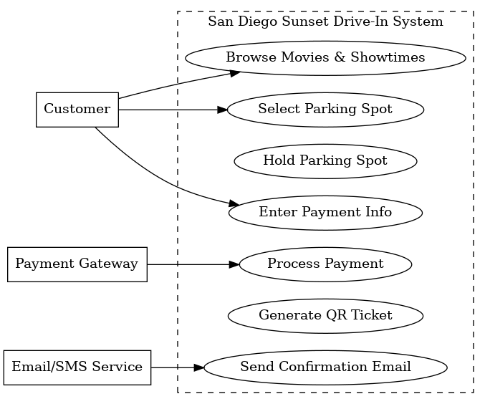

### 3.3.2 UC-2: Validate Tickets at Entry

* **Actor(s):** Staff (ticket validator)
* **Purpose:** Personnel verify customer entry into the theater.
* **Preconditions:** The customer possesses a valid QR ticket; the staff device is equipped with scanning capabilities.
* **Flow of Events:**  
  1. The customer presents a QR code upon entry.
  2. The personnel member utilizes a validation device to scan the ticket.
  3. The system executes a verification of the ticket status.
  4. If valid and not previously redeemed, the system designates it as Redeemed and grants access to the customer.
* **Extensions:**  
  1. Already Redeemed → Any individual who has already been redeemed should be denied entry, and the staff must be duly notified.
  2. Invalid ticket → entry will be denied.
  3. Offline mode → scan queued locally and synchronize when the connection is restored.
* **Postconditions:** The ticket has been marked as Redeemed; the occupancy count has been subsequently updated.

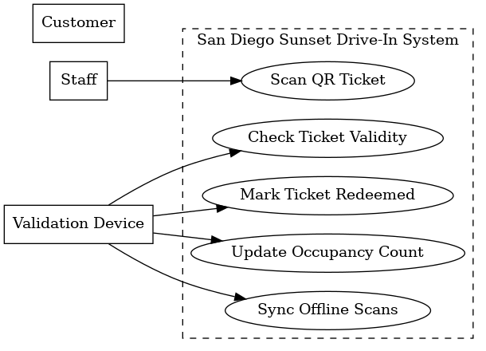

**3.3.2 UC-3: Manager Publishes Schedule**

* **Actor(s):** Manager
* **Purpose:** The manager develops and disseminates a daily or weekly program of movies and showtimes.
* **Preconditions:** The system is configured with movie schedules and parking layouts.
* **Flow of Events:**  
  1. The manager opts to select 'Create Schedule' on the dashboard.
  2. The manager allocates movies to specific showtimes and provides parking maps.
  3. The manager establishes the pricing tiers and promotional regulations.
  4. The system performs validation to identify conflicts such as overlaps and capacity issues.
  5. The manager publishes the schedule, enabling customers to browse and purchase tickets.
* **Extensions:**  
  1. Time conflict detected → The system prompts the manager to make adjustments.
  2. Pricing error → Please highlight and request correction.
* **Postconditions:** The schedule has been marked as 'On-Sale', and showtimes are available to customers through all channels.

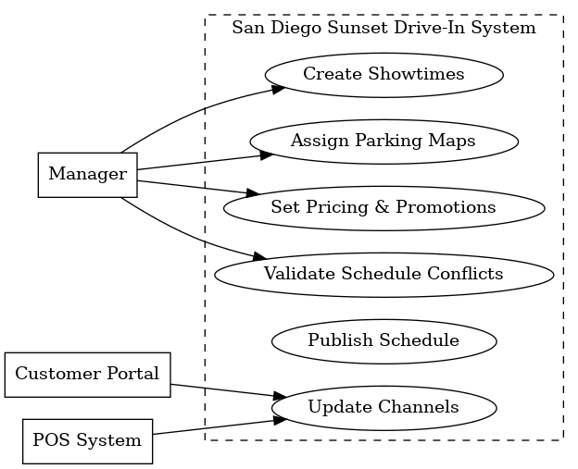

…

## 3.4 Classes & Objects

This section defines the primary classes and objects of the SDSDIMS, their attributes, and their functions.

**3.4.1 Movie**

* **Attributes:** movieID, title, duration, rating, genre
* **Functions:** getShowtimes(), addShowtime()
* This relates to the Movie setting functional requirement

**3.4.2 Showtime**

* **Attributes:** showtimeID, movie, startTime, endTime, parkingLayout
* **Functions:** reserveSpot(), releaseSpot(), sellTicket()
* This relates to the Movie showtime functional requirement

**3.4.3 Parking Spots**

* **Attributes:** spotID, location, layoutType, isAvailable
* **Functions:** hold(), confirmReservation(), release()
* This relates to the Parking Spot Reservation functional requirement

**3.4.4 User**

* **Attributes:** userID, name, email, role, paymentInfo
* **Functions:** login(), updateProfile()
* This relates to the Payment Processing functional requirement

**3.4.5 Ticket**

* **Attributes:** ticketID, showtime, parkingSpot, user, QRcode, status
* **Functions:** validate(), markRedeemed()
* This also relates to the Payment Processing functional requirement

**3.4.6 Concession Item**

* **Attributes:** itemID, name, price, stockQuantity
* **Functions:** reduceStock(), replenishStock()
* This relates to the Concession Ordering functional requirement

## 3.5 Non-Functional Requirements

### 3.5.1 Performance

1. **NFR-P1:** The system shall display movie listings and parking availability within a timeframe of 2 seconds for 95% of requests.
2. **NFR-P2:** Ticket purchase transactions shall be completed (from payment submission to confirmation) within five seconds under normal operating conditions.
3. **NFR-P3:** The system shall accommodate up to 2,000 concurrent customer sessions without any deterioration in response time.

### 3.5.2 Reliability

1. **NFR-R1:** The system shall possess a Mean Time Between Failures (MTBF) of no less than 30 days.
2. **NFR-R2:** Critical failures, such as payment processing errors and ticket validation system crashes, shall be recoverable within a timeframe of fifteen minutes.
3. **NFR-R3:** Data integrity must be upheld in all transactions; no more than 0.01% of ticketing transactions are permitted to result in data corruption or inconsistency.

### 3.5.3 Availability

1. **NFR-A1:** The system shall be operational 99.9% of the time within each calendar month, excluding scheduled maintenance periods.
2. **NFR-A2:** Ticket validation devices shall support offline scanning for up to two hours, with synchronization occurring automatically once connectivity is restored.
3. **NFR-A3:** Scheduled maintenance downtime shall not exceed four hours per month and must occur outside peak operating hours.

### 3.5.4 Security

1. **NFR-S1:** All communications shall be encrypted utilizing TLS 1.2 or a higher version.
2. **NFR-S2:** Sensitive customer data (e.g., PII, order history) shall be stored encrypted at rest using **AES-256**.
3. **NFR-S3:** Access to staff and manager dashboards shall employ role-based access control (RBAC), with managers mandated to utilize multi-factor authentication (MFA).
4. **NFR-S4:** The system shall conform to PCI-DSS standards, guaranteeing that no unencrypted credit card data is retained on SDSDIMS servers.

### 3.5.5 Maintainability

1. **NFR-M1:** A minimum of 70% code coverage shall be maintained through automated testing for business logic.
2. **NFR-M2:** System updates and configuration changes (e.g., pricing, promotions) shall be deployable without requiring system downtime.
3. **NFR-M3:** Documentation shall be updated with each release; changes must be reflected in the SRS/design documents within five business days of deployment.

### 3.5.6 Portability

1. **NFR-PT1:** Customer-facing applications shall operate on all major browsers, including Chrome, Firefox, Safari, and Edge, within their most recent two versions.
2. **NFR-PT2:** Mobile access shall be supported on devices operating with iOS 14 or later and Android 10 or later.
3. **NFR-PT3:** Staff and manager dashboards shall be accessible on both Windows 10 and later versions, as well as macOS 12 and later versions.
4. **NFR-PT4:** Migration to a new hosting environment, whether cloud-based or on-premises, should necessitate no more than two weeks of effort, with no modifications to the business logic.

## 3.6 Inverse Requirements

State any *useful* inverse requirements.

## 3.7 Design Constraints

Specify design constrains imposed by other standards, company policies, hardware limitation, etc. that will impact this software project.

## 3.8 Logical Database Requirements

Will a database be used? If so, what logical requirements exist for data formats, storage capabilities, data retention, data integrity, etc.

## 3.9 Other Requirements

Catchall section for any additional requirements.

# 4. Analysis Models

List all analysis models used in developing specific requirements previously given in this SRS. Each model should include an introduction and a narrative description. Furthermore, each model should be traceable the SRS’s requirements.

## 4.1 Sequence Diagrams

## 4.3 Data Flow Diagrams (DFD)

## 4.2 State-Transition Diagrams (STD)

# 5. Change Management Process

Identify and describe the process that will be used to update the SRS, as needed, when project scope or requirements change. Who can submit changes and by what means, and how will these changes be approved.

# 6. Software Design Specifications

# 6.1 System Description

The San Diego Sunset Drive-In Management System (SDSDIMS) is a three-tier web platform that supports all aspects of drive-in operations: public movie browsing and ticket purchase; staff tools for on-site sales and ticket validation; and a manager dashboard for scheduling, pricing/promotions, concessions, and reporting. Customers can browse showtimes, select a parking spot on an availability map, and buy tickets and concessions via a secure, mobile-friendly interface. Staff utilize a POS system and a scanner application (which can operate offline) to validate QR/barcode tickets at the entrance and manage walk-up sales. Managers publish schedules, oversee inventory, and review analytics on sales, parking occupancy, and promotional effectiveness.

Architecturally, the system employs a single API Gateway (BFF) to serve all clients. Core domain services, such as Movie & Showtime, Parking (with short-term “hold” logic), Ticketing (QR code generation and validation), Concessions & Inventory, Payments (integrated with Stripe/PayPal), Notifications (Email/SMS), Reporting/Analytics, and Authentication (RBAC+MFA), maintain state within a relational database and utilize a cache for operations with high contention (such as spot holds). A message broker transmits domain events (e.g., TicketPurchased, SpotReleased) to facilitate workflow decoupling and support analytics. All payment transactions are processed through PCI-compliant processors; no raw PAN data is stored within SDSDIMS.

**6.2 Software Architecture Overview**

# 6.2.1 Architecture Diagram

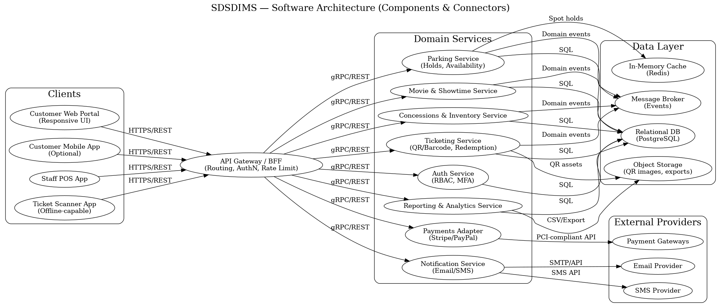

# 6.2.2 Architecture Explanation

Clients (Customer Web, optional Mobile, Staff POS, and Scanner) access the API Gateway over HTTPS. The gateway manages routing, authentication, and rate limiting, and forwards requests to domain services via REST/gRPC. Authentication handles RBAC and MFA; Movie & Showtime services publish schedules; Parking manages availability and time-boxed holds backed by a cache; Ticketing issues and redeems QR/Barcode tickets, storing QR assets in object storage; Concessions and Inventory record on-site and pre-orders; Payments integrate with external gateways; Notifications send email and SMS messages; Reporting aggregates events for dashboards and exports. Services persist data to a relational database and publish domain events to a broker to maintain decoupling (e.g., a purchase triggers notifications and inventory updates). External providers (payments, email, SMS) are accessed via provider APIs.

# 6.3 UML Class Diagram

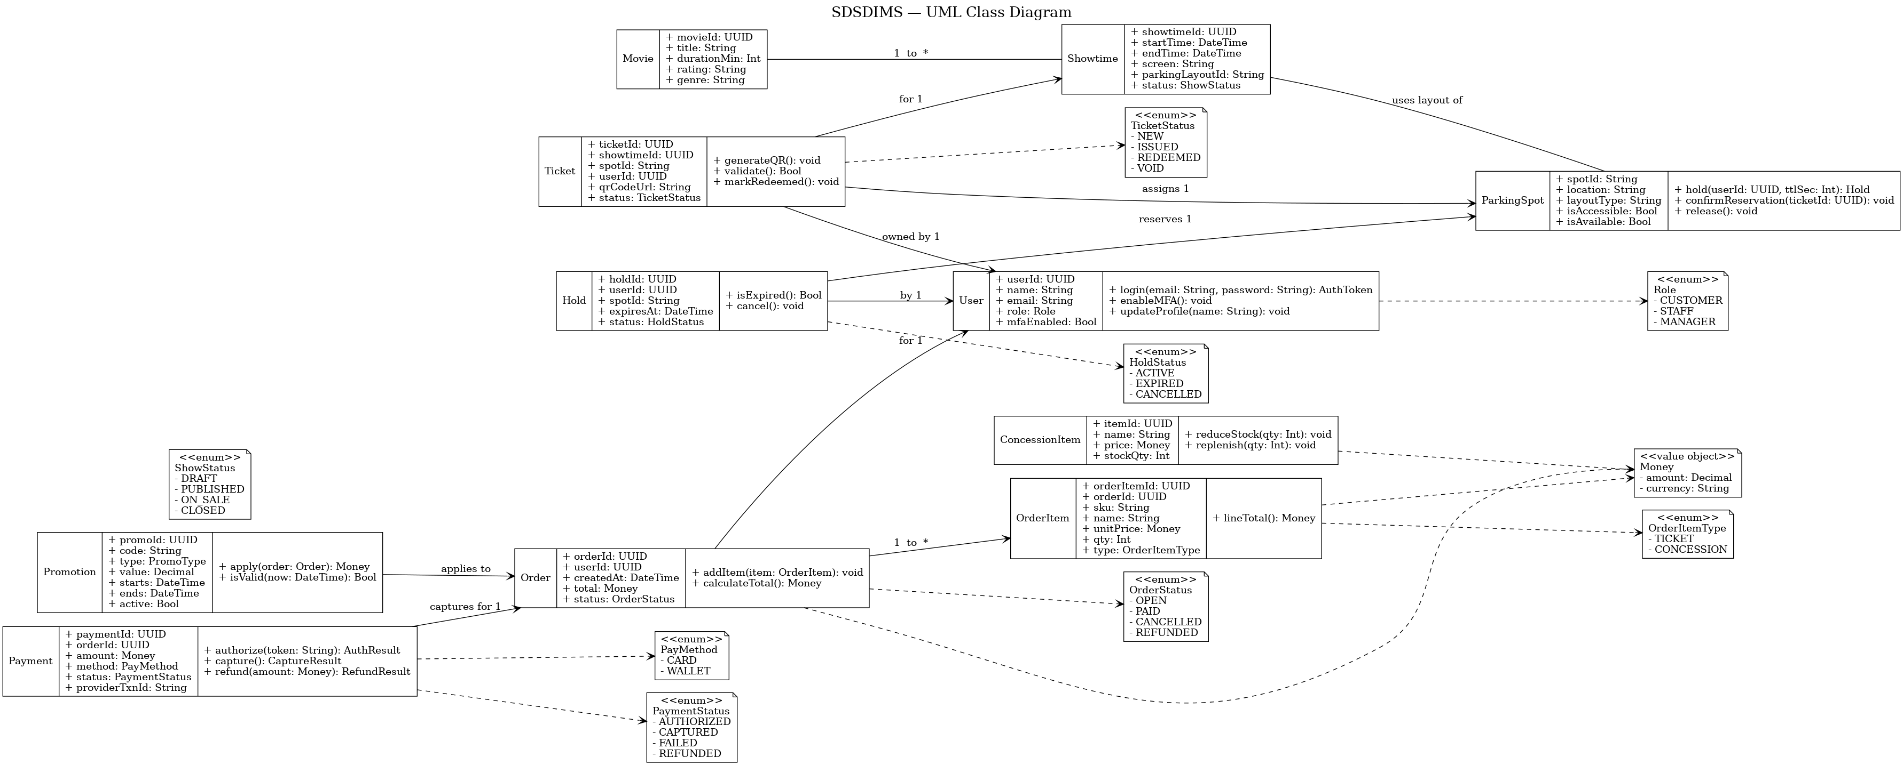

# 6.4 Class Descriptions

The SDSDIMS domain model centers on users purchasing tickets and concessions for scheduled movies. A User logs in, manages a profile, and holds a role that determines access (Customer, Staff, or Manager). Each Movie has multiple Showtimes, which define times and parking layouts. ParkingSpots can be held or reserved through Hold objects, then converted into Tickets containing QR codes for entry validation. Orders group tickets and concessions together, linked to a Payment record and optional Promotion discount. ConcessionItems maintain stock quantities and prices for food and drink sales. Relationships among these classes ensure that each transaction, from reservation to redemption, is securely tracked and easy for both staff and management to manage.

# 6.5 Development Plan and Timeline

The San Diego Sunset Drive-In Management System will be developed through three principal phases: setup, implementation, and testing/deployment. Responsibilities will be distributed among all team members to guarantee equitable contributions and detectable GitHub commits from each participant.

**Phase 1 – System Setup (Week 1):**  
 Seth V. initializes the GitHub repository, establishes the foundational project structure, and integrates essential frameworks for the web portal and API gateway. Christena B. prepares initial HTML/CSS templates and configures page routing. Oscar D. sets up the relational database schema, defining tables for users, movies, and showtimes.

**Phase 2 – Core Implementation (Weeks 2-3):**  
 Seth V. is responsible for implementing authentication, movie management, and parking reservation APIs. Christena B. facilitates the integration of front-end interfaces for browsing movies, processing checkouts, and displaying tickets, ensuring they are responsive. Oscar D. develops the ticket validation module, concession sales interface, and reporting endpoints. All team members perform local testing of their respective modules and submit updates on a weekly basis.

**Phase 3 – Integration and Testing (Weeks 4-5):**  
 The team collaboratively conducts integration testing of payment processes, QR code validation, and reporting accuracy. Seth manages GitHub issue tracking and pull requests; Christena supervises UI refinement and accessibility assessments; Oscar is responsible for database optimization and deployment packaging. Upon verification, the final version of the consolidated SRS and SDS documents, along with architecture and UML diagrams, is uploaded to GitHub, with each team member confirming at least one commit.

Deliverables will be integrated via peer-reviewed pull requests to ensure traceability and uphold quality standards. This phased schedule guarantees consistent progress, code cohesion, and transparent collaboration documentation for evaluation purposes.

# A. Appendices

Appendices may be used to provide additional (and hopefully helpful) information. If present, the SRS should explicitly state whether the information contained within an appendix is to be considered as a part of the SRS’s overall set of requirements.

*Example Appendices could include (initial) conceptual documents for the software project, marketing materials, minutes of meetings with the customer(s), etc.*

## A.1 Appendix 1

## A.2 Appendix 2